- How to activate the school mail
- Open this URL: www.outlook.com/mak-hhhs.edu.lb
- Type in your email, click next then type in your password:
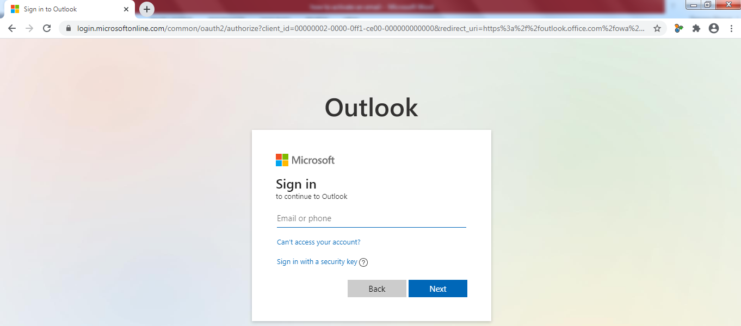

- As a first login, you have to change your password. The new password format must contain one capital letter + numbers + special characters.

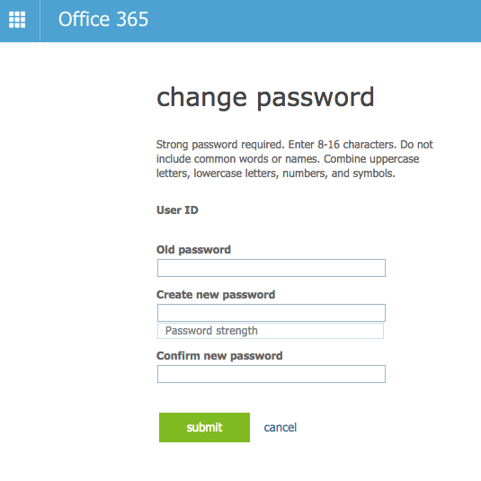

- Then click Submit.

- How to download Microsoft Teams.
- Open the following webpage: https://www.microsoft.com/en/microsoft-365/microsoft-teams/download-app

- Click on “Download for desktop” in the following webpage:
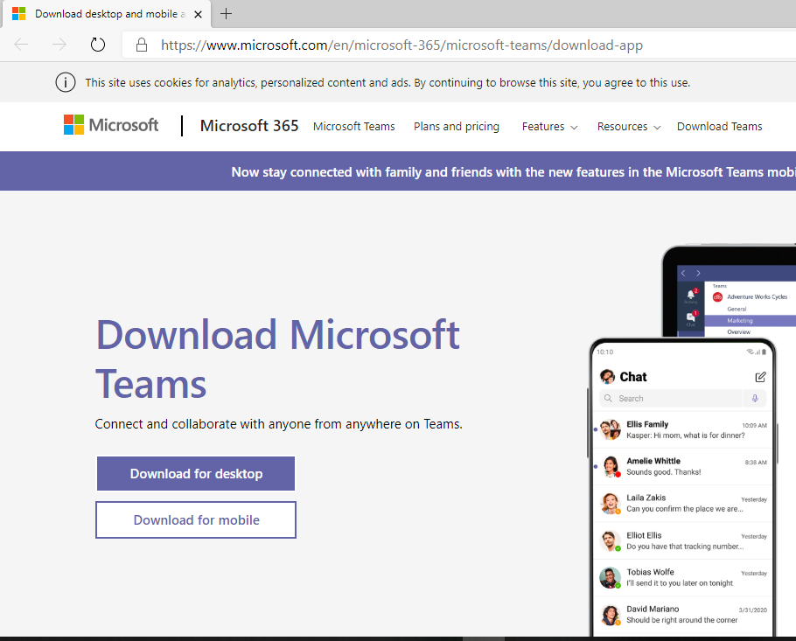
- Then click “Download Teams”:
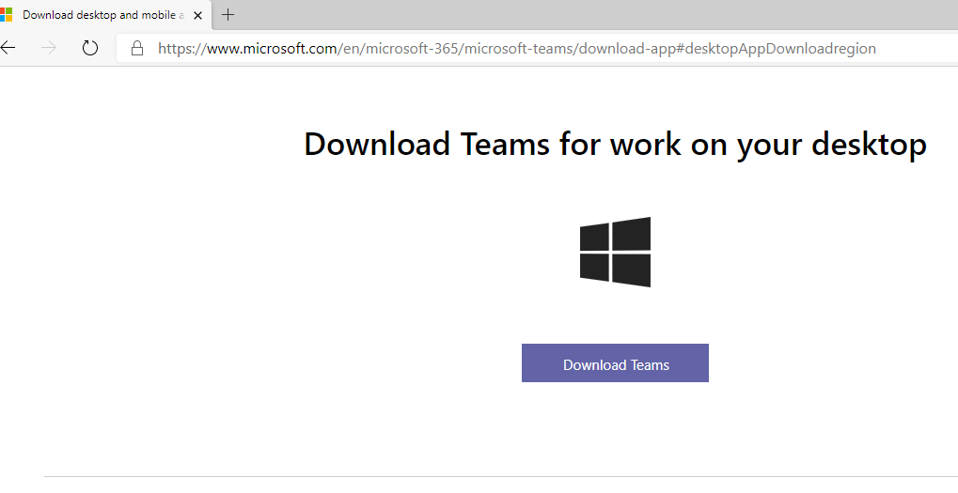
- Then click “Run” below:
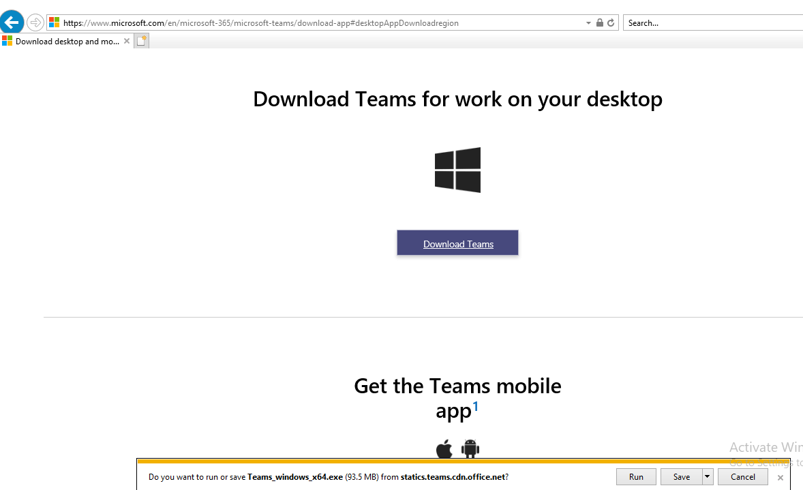

- When the download is done, Microsoft Teams Login Window will open on your desktop:

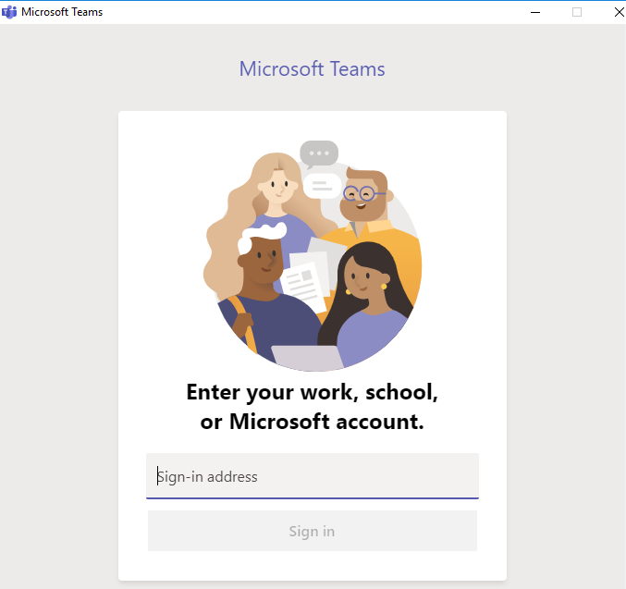

- And you will find the shortcut icon of the application on your desktop :
